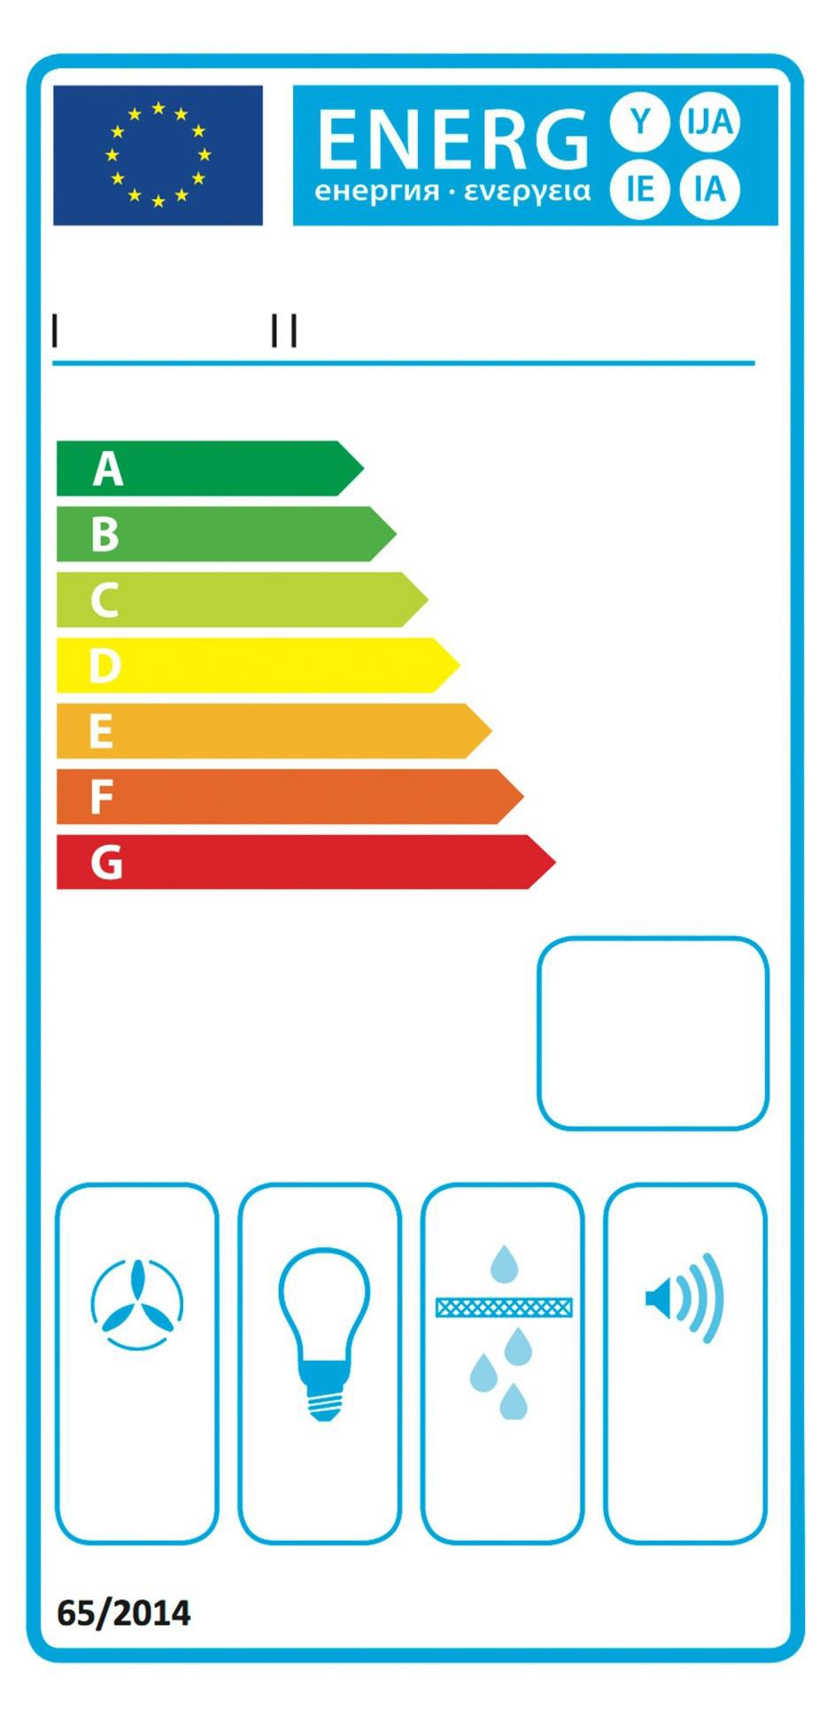

MF-A-TOU-50-B-60

A

38,24

kWh/annum

ABCDEFG ABCDEFG ABCDEFG 54/66
dB

